Stem Cells Build “Biobridges” to Aid Brain Repair
November 7, 2013 by mburatov

University of South Florida (USF) scientists have suggested a new strategy for stem cell-mediated brain repair following trauma.
In several preclinical experiments, the USF group found that transplanted stem cells build a “biobridge” that links an injured site in the brain to a site where neural stem cells form.
Principal investigator, Cesar Borlongan, professor and director of the USF Center for Aging and Brain Repair, said: “The transplanted stem cells serve as migratory cues for the brain’s own neurogenic cells, guiding the exodus of these formed host cells from their neurogenic niche towards the injured brain.”

On the strength of these preclinial studies in laboratory animals, the US Food and Drug Administration recently approved a limited clinical trial to transplant SanBio Inc.’s SB632 cells into patients with traumatic brain injuries. SB632 cells are a proprietary product of SanBio, Inc., and SB632 cells are derived from mesenchymal stem cells but they have been genetically engineered to express the intracellular domain of the Notch protein (NICD; see C. Tate, et al., Cell Transplantation, Vol. 19, pp. 973–984, 2010). If the Notch protein, which functions as a signaling protein and normally sits in the cell membrane, has its outer piece removed, the protein is constitutively activated. This full-time activation of the Notch protein and its downstream targets drive SB632 cells to form neural cells; something that mesenchymal stem cells typically do not readily make.
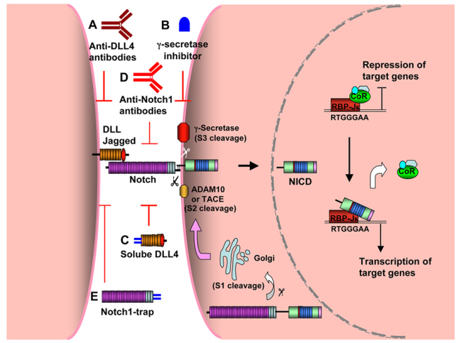
The Notch pathway. Notch is synthesised as a precursor protein that is processed by a furin-like convertase (S1 cleavage) in the Golgi before being transported to the cell surface, where it resides as a heterodimer. Interaction of Notch receptors with Notch ligands, such as Delta-like or Jagged, between two bordering cells leads to a cascade of proteolytic cleavages. The first cleavage (S2 cleavage) is mediated by ADAM-family metalloproteases such as ADAM10 or TNF-alpha-converting enzyme (TACE, also known as ADAM17), generating a substrate for S3 cleavage by the gamma-secretase complex. This cleavage releases the Notch intracellular domain (NICD) from the cell membrane. NICD then translocates to the nucleus, where it interacts with the DNA-binding protein RBP-Jkappa (also known as CBF1) and cooperates with Mastermind to displace corepressor proteins, thus activating the transcription of Notch target genes. The basic helix-loop-helix proteins hairy/enhancer of split (such as Hes1, 5 and 7) and Hes-related proteins (Hey1, 2 and L) and EphrinB2 are the best characterised downstream targets. Blockade of Notch signalling has been achieved by using different strategies, including (A) anti-DLL4 monoclonal antibodies, (B) gamma-secretase inhibitors such as DBZ and DAPT, (C) soluble DLL4-Fc, (D) anti-Notch1 neutralising antibodies, and (E) Notch1-trap.
While this over-simplifies the field to some extent, there are two views on how stem cells heal brain damage caused by injury or neurodegenerative disorders. One view postulates that stem cells implanted into the brain directly replace dead or dying cells by differentiating into neurons and glial cells. The other view is that transplanted stem cells secrete growth factors that indirectly rescue the injured tissue. This present USF study argues for a third view, namely that implanted stem cells for a causeway in the brain between damaged areas and those anatomical structures that give birth to neural stem cells.
In this USF study, Borlongan and his group randomly assigned rats with traumatic brain injury and confirmed neurological impairment to one of two groups. The first group received transplants of SB632 cells into the region of the brain affected by traumatic injury. The second group received a sham procedure in which solution alone was infused into the brain with no implantation of stem cells.
At one and three months post-TBI (traumatic brain injury), the rats that had received SB632 transplants showed significantly better motor and neurological function and reduced brain tissue damage when compared to rats that had received no stem cells. These robust improvements despite the fact that the transplanted stem cells showed fair to poor survival that diminished over time.
Next, Borlongan’s laboratory workers examined the brain tissue of these rats. At three months post-TBI, the brains of transplanted rats showed massive cell proliferation and differentiation of stem cells into neuron-like cells in the area of injury. This was accompanied by a solid stream of stem cells that had migrated from the brain’s uninjured subventricular zone (where many new stem cells are formed) to the brain’s site of injury.
In contrast, those rats that had received solution alone showed limited proliferation and neural-commitment of stem cells, and only showed scattered migration to the site of brain injury and almost no expression of newly formed cells in the subventricular zone. Thus, without the addition of transplanted stem cells, the brain’s self-repair process appeared insufficient to mount a defense against the cascade of TBI-induced cell death.
Borlongan concluded that the transplanted stem cells create a neurovascular matrix that bridges the gap between the region in the brain where host neural stem cells arise and the site of injury. This pathway, or “biobridge,” ferries the newly emerging host cells to the specific place in the brain in need of repair, and helps them to promote functional recovery from traumatic brain injury.

